**Lab Report No 6**



**Digital Signal processing**

**Submitted By: Muhammad Ali**

**Registration No: 19pwcse1801**

**Submitted to : Sir Ihsan-ul-haq**

**Section: A**

**Date: 12/2/2022**

**Department of Computer Systems Engineering**

**University of Engineering and Technology Peshawar**

**Tasks no 1-4: -**In this task we have develop a baseband composite signal of named ‘x’ and modulate with carrier (Fc), sampled (Fs) and deviation (Fd) frequencies using ‘fmmod’ function. Then we examine the modulated signal of some deviation as well as increase in deviation. To check whether the original baseband signal is received correctly at the receiver end or not we have to demodulate the modulated signal with the same carrier.

Code: -

clc

close all

clear all

fs = 1000;

fc=200;

t=0:1/fs:0.2;

fd=50;

%step no 1: -making some composite baseband signal

x= sin (2*pi*30*t) + 2*sin (2*pi*60*t) ;

%using fmmod function for frequency modulation

y= fmmod (x,fc,fs,fd);

plot(t,x,'g',t,y,'r--');

title('baseband and carrier signals in time-domain');

xlabel('time');

ylabel('Amplitude');

% step no 2: -frequency modulation with more deviation

fd=100;

figure;

out= fmmod (x,fc,fs,fd);

plot(t,x,'g',t,out,'r--');

title('baseband and carrier signals in time-domain');

xlabel('time');

ylabel('Amplitude');

% step no 3: -using fmdemod function for frequency demodulation

figure;

demodu= fmdemod(out,fc,fs,fd);

plot(t,x,'g',t,demodu,'r--');

title('demodulated signal in time-domain');

xlabel('time');

ylabel('Amplitude');

Step # 1: -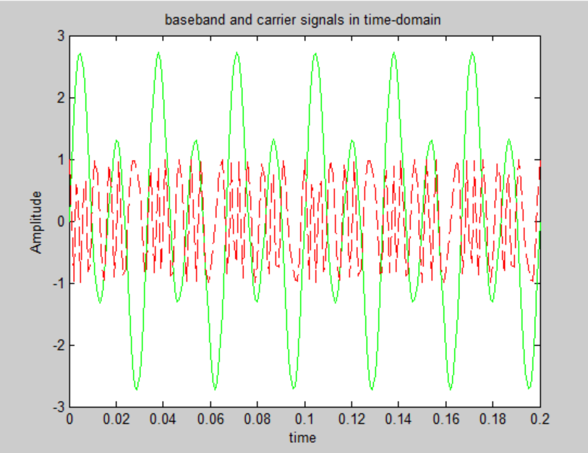

Step # 2: -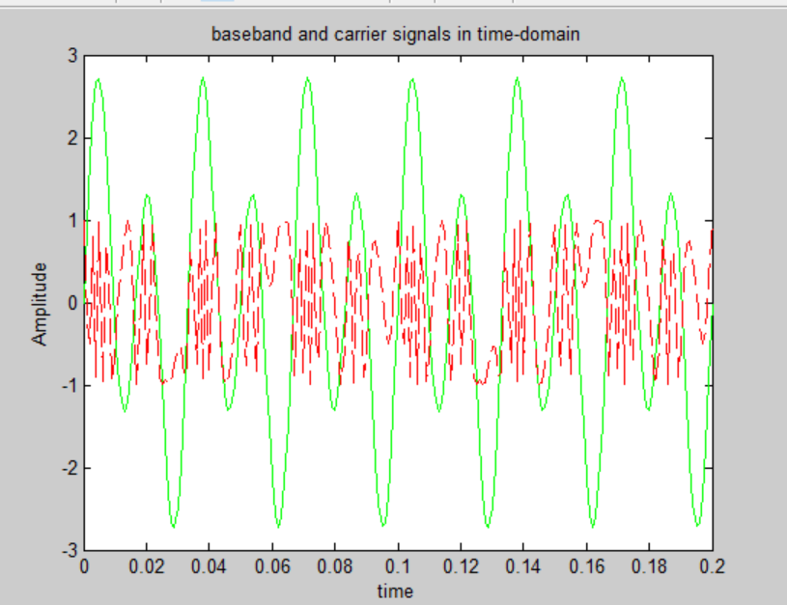

Step # 3: -

